9.16: From Eq. (9.7), with 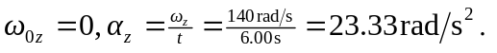The angle is most easily found from

